**Objective Questions**

1. In analysing the dataset with Power BI, ensure data cleaning to address inconsistencies and missing values before further analysis.

- From the given data, I have utilized the power query editor for data cleaning and consistency.

- Such as removing Excess empty columns, changed data type, replaced value few null values, Removed Duplicates in Order id.

1. How can we calculate the total revenue generated by all the sales?

-Using DAX formula SUM () with the sale price we can calculate the revenue

and visualised using the Card visual in Report view.

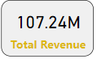

1. What is the total number of unique customers who made purchases in each year? Is there any increase in the number over the years?

-Using DAX formula DISCTINCTCOUNTNOBLANK () for Customer ID from the data table and named as “Total number of customers”.

-To visualise the unique customers in each year. I have utilised the Line chart in which x-axis is selected as ‘year’ from the order date and y-axis as Total number of customers.

-And customers from the year 2020 have increased in number of customers   
 which was ‘25179’ when compared to the previous year 2019 which was ‘17537’.

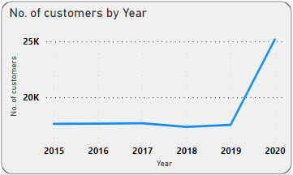

1. How can we determine the total number of unique products available in the company?

-Using DAX formula DISTINCTCOUNT () for Product we can determine the total number of unique products and to visualise I have selected the Card visual and established in Main Tab.

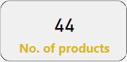

1. What is the average number of days it takes for products to be delivered, get the metric for only the delivered orders?

-Using Dax formula DATEDIFF function for order date and delivery date to create a conditional column to identify the number of days to deliver and named as “number of days to deliver”.

-Using AVERAGE () function for ‘number of days to deliver’ to find out Average delivery days.

-And to get average days for delivered products I have used the

CALCULATE () function.

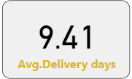

1. Which products, categories, and subcategories are the most popular?

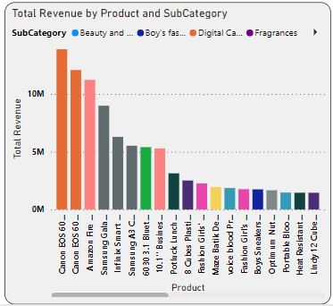

* From the given data I have used the stacked column chart in which product in x-axis, Total revenue in y-axis and sub category in legends.
* From the above chart we can find that “Electronics” of Product category, Digital camera of Sub-category,

“Canon EOS 18MP CMOS DSLR Camera-black” of Product are most popular.

1. Which products have seen an increase or decrease in sales over the year?

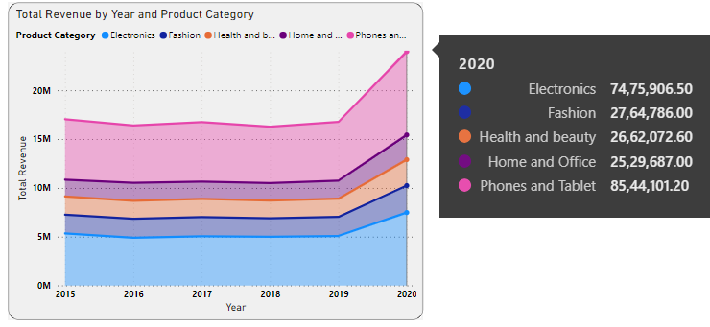

* From the above line chart, we can identify that there is

Decrease in sales in the year-2018 compared to 2017 sales and

Increase in sales in the year-2020 when compared to previous year-2019.

**Subjective Question**

1. How does revenue break down by year and by-product? Evaluate how different products contribute to annual revenue and come up with suggestions to increase the sales of the low-selling items.

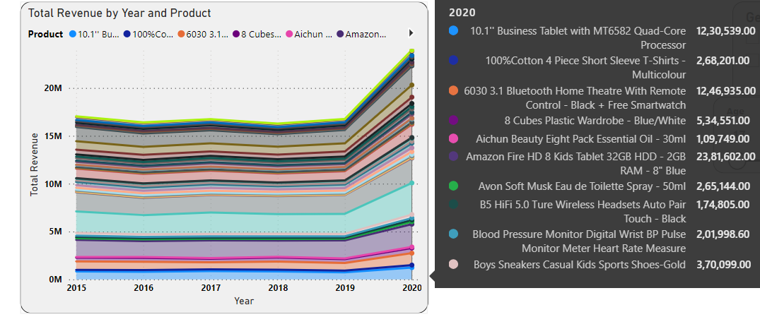

- Offer Deals and Promotions: These things enhance the appeal and saleability of products. Before deciding what to buy, customers frequently look through and even wait for promotional deals such as free product offers, customized claim codes, and discounts.  
  
- Create your Prime Eligible for Amazon:  
Unlimited free one-day and two-day merchandise deliveries are a benefit of having an Amazon Prime membership.  
  
- Promote Customer comments:  
Every purchase should be followed by great customer service to enhance the buying experience.

1. How many products were returned? Examine the possible reasons for returns and consider how this metric could inform improvements in product descriptions or quality control.

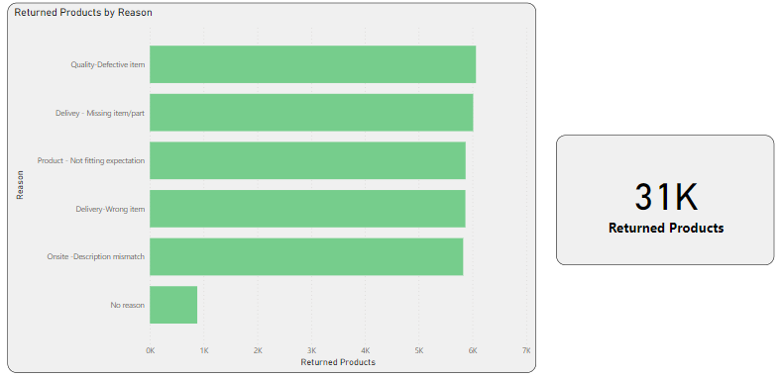

-From the overall 31k returned products the most possible reasons for returned products is due to Defective items were delivered.

1. Whenever a customer goes to Amazon, they’ll filter the most rated products in order to buy the better category. Can you verify this using any visualization or table that the ratings of products impact their sales value?

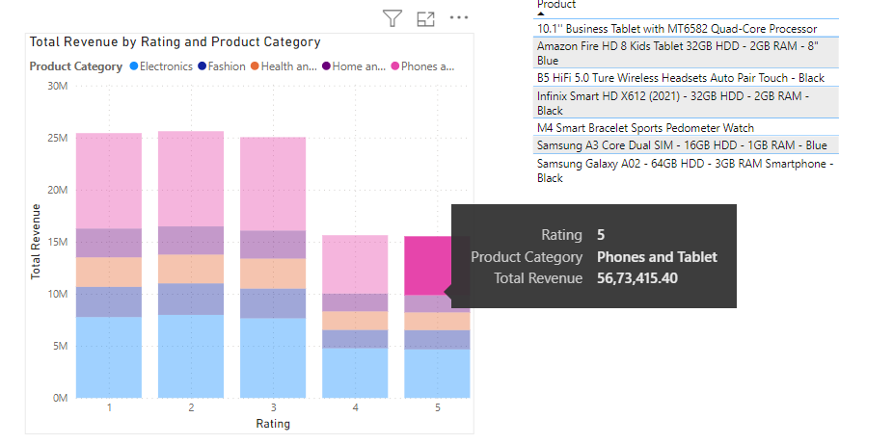

-From the given data the revenue is good for less rated products are because low rated products are affordable for every class of people and by improving the quality of the product and delivering the product carefully the rating of products might change and it will impact the sales.

1. Investigate how revenue distribution varies across different locations. Explore which geographical areas contribute most to sales and consider the strategic implications for regional marketing and distribution efforts. How might location-based trends inform the company's approach to market segmentation and resource allocation?

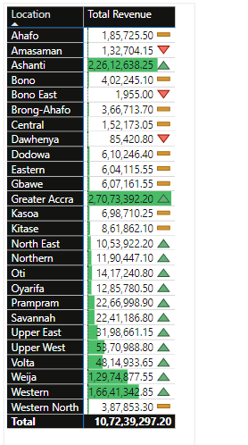

-From the above table we can identify areas like Greater Accra, Ashanti, western and Weija are places with Highest Revenue is generated.

-The success of marketing initiatives can be increased by enhancing marketing techniques such utilizing local language, images, cultural references, and promotional offers that connect with the community in areas like Bono East, Dawhenya, Amasaman.

1. Determine which month could benefit from enhanced promotional offers to boost sales. Can you suggest some targeted marketing strategies here?

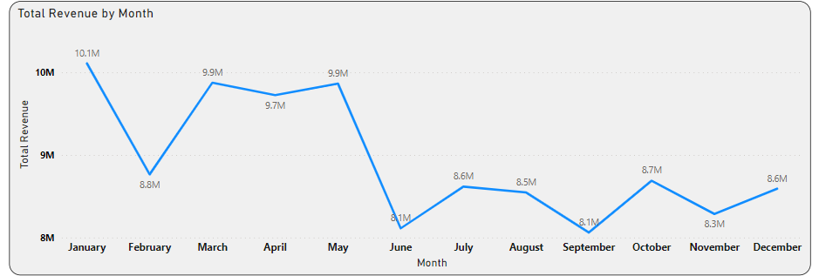

* From the above graph we can observe that January month has its high revenue most likely due to festival season and better campaigns.
* And in the month of June and September has lesser revenue generated compared to other months
* Festival-themed Campaigns: Create marketing campaigns that resonate with the spirit of specific festivals, incorporating relevant imagery, colours, and messaging.
* Regional Targeting: Tailor promotions to specific regions in India where certain festivals or cultural events hold greater significance, ensuring relevance to local customs and traditions.
* Mobile Marketing: Utilize mobile marketing channels such as SMS marketing, mobile apps, and push notifications to reach consumers directly on their smartphones, especially in a mobile-first market like India.
* Cashback and Wallet Offers: Partner with digital payment platforms and offer cashback or discounts for transactions made through their services, encouraging online purchases and driving customer engagement.
* Influencer Collaborations: Partner with influencers or celebrities popular in India to promote your products through social media platforms and reach a larger audience.
* Localized Advertising: Create ads in regional languages and dialects to connect with consumers in different parts of India, recognizing the diversity of language and culture across the country.

1. Identify which products may require increased marketing efforts. Which items have high prices yet underperform in sales?

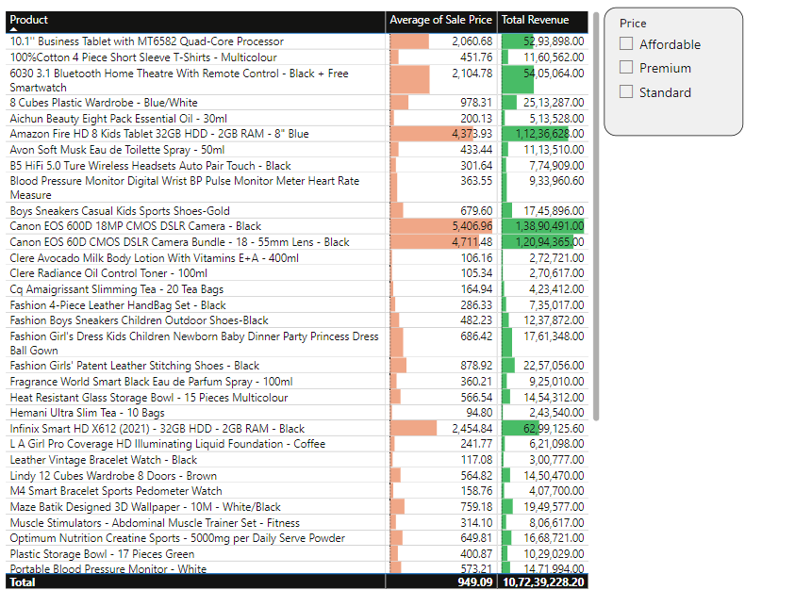

-Despite of having the high-priced products like

* Samsung Galaxy A02-64GB HDD -3GB RAM Smartphone-Black
* Amazon Fire HD 8 kids tablet 32GB hdd-2gb ram-8 Blue

Are Under preformed and these products required increased marketing efforts and Promotional offers to boost the sales.

1. Assess which products should have discounts. How can targeted incentives drive sales and customer loyalty for specific products?

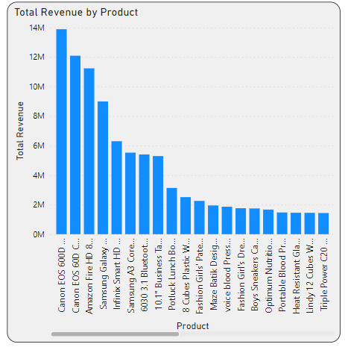

-Targeted incentives can be a highly effective strategy for driving sales and customer loyalty for specific products by increasing relevance, influencing behaviour, promoting underperforming products, enabling segmentation and personalization, rewarding customer loyalty, and encouraging feedback and engagement can create a more compelling and rewarding experience for customers, ultimately driving growth for such products in the market.

1. Come up with a loyalty program to benefit the company’s customers. From the available lot of customers come up with strategies to bucket them and provide benefits under different loyalty programs.

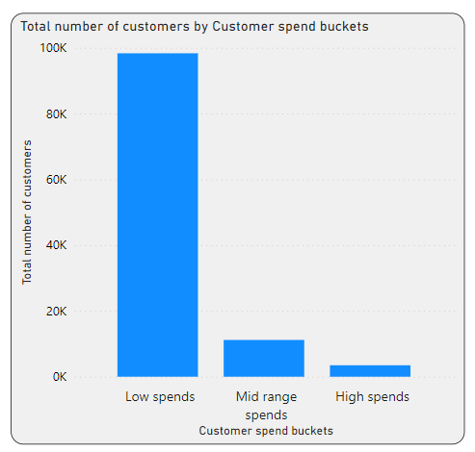

* **Low Spend Bucket (Bronze):**

Benefits:

Points for every purchase: Low spend customers earn a small number of loyalty points for every purchase they make.

Birthday discount: A small discount or special offer is given to customers on their birthdays.

Recognition: Customers in this tier are acknowledged as valued members of the loyalty program, even though their spending may be lower compared to other tiers.

Exclusive promotions: Access to exclusive promotions, sales, or product launches to incentivize repeat purchases.

* **Mid-Range Spend Bucket (Silver):**

Benefits (includes all benefits from the bronze tier, plus):

Accelerated points: Mid-range spend customers earn loyalty points at a faster rate than low spend customers.

Tier-specific promotions: Special promotions or discounts available only to customers in the mid-range spend tier.

Early access: Exclusive early access to sales, new product releases, or events.

Personalized offers: Tailored offers based on purchase history and preferences to enhance the customer experience and encourage repeat purchases.

* **High Spend Bucket (Gold):**

Benefits (includes all benefits from the bronze and silver tiers, plus):

VIP treatment: Dedicated customer service representatives, priority access to support channels, and personalized assistance.

Bonus points: High spend customers receive bonus loyalty points or cashback rewards on their purchases.

Elite events: Invitations to exclusive events, product previews, or VIP experiences.

Freebies and perks: Free samples, exclusive gifts, or complimentary upgrades as a token of appreciation for their loyalty and high spending.

1. **Wait Times Correlated with Demographics and Care:** Explore how average wait times vary across different product categories to optimize scheduling and staffing.

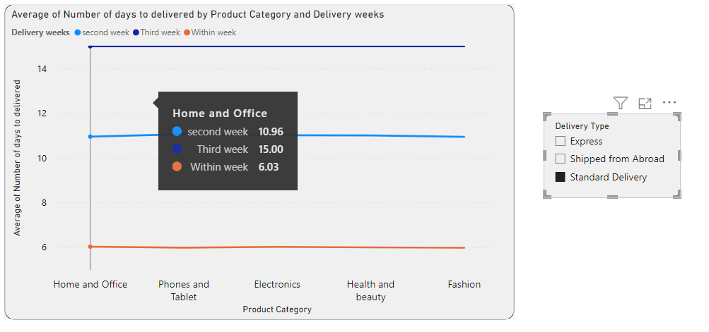

-The Average time for various product categories correlated with Type of delivery and product category. From the above graph the standard delivery wait time refers the second week of delivery.

1. Explore if there is any relationship between the Delivery type and waiting time between ordering and receiving an item.

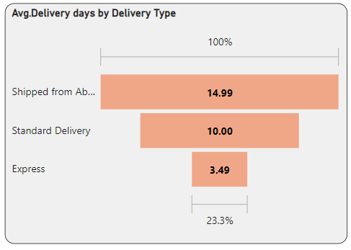

- The average days to deliver a product is based on the type of delivery in which product delivered by Express is 3.4 days which is Fastest delivery type.

- The standard delivery has 10 days of average delivery days and the product shipped from Abroad has average of 14.99 days.

1. Is there any relationship between shipping charges and product type?

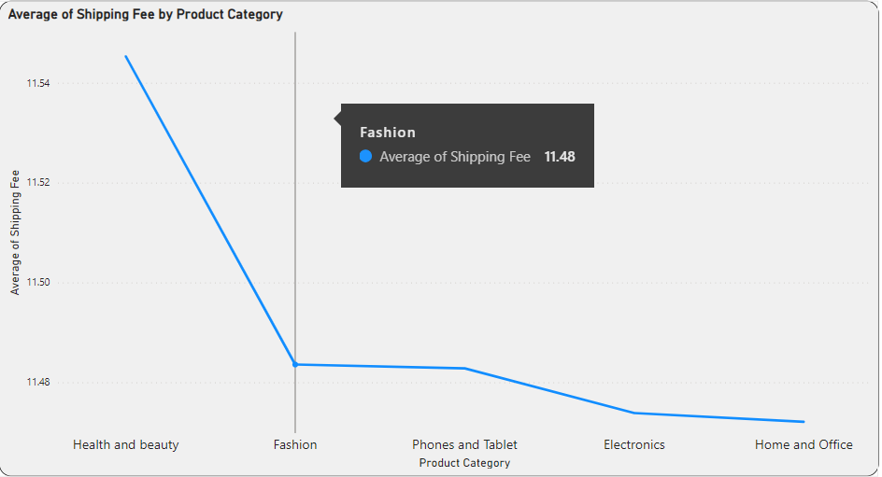

* The average of shipping fee for all the product types are almost similar.

1. Come up with strategies to decrease the low rating orders after analysing different factors like waiting time, shipping type, unit price, etc.

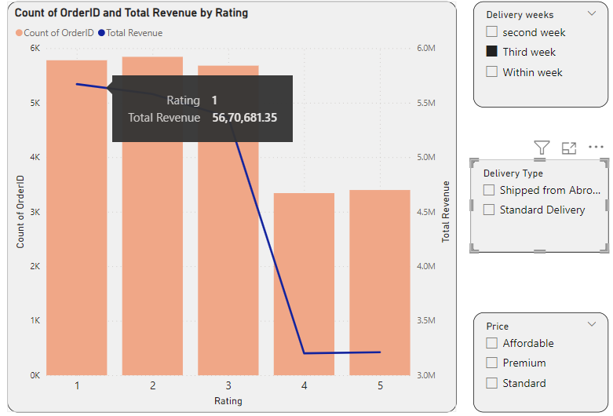

Improve inventory management: Ensure that popular items are adequately stocked to reduce waiting times.

Shipping Type:

Offer free shipping: Consider absorbing shipping costs into the product price or offering free shipping for orders above a certain threshold.

Price optimization:

Bundle discounts: Encourage customers to purchase multiple items by offering discounts for bundle purchases, which can increase the perceived value of the products.

Act on feedback:

Use the insights gained from customer feedback to identify areas for improvement and make necessary adjustments to enhance.

Ensure product quality:

Conduct regular quality checks to maintain high standards for your products, reducing the negative reviews due to defective items.

Improve packaging:

Invest in sturdy packaging materials to protect products during transit and minimize the risk of damage or breakage.